Dear Year 11
I hope you were able to enjoy your last day at UCC last week. I still cannot believe how quickly everything changed over the course of a few days; I can only imagine how it must have felt for you all. Last Friday was a surreal day, but it was wonderful to see you enjoying your final day at UCC with your peers and the staff. Like I said to you all in my assembly, we are very proud of you as a year group and you have been superb role models for our younger students. I hope you look back on your time at UCC with happiness and fond memories. I also hope you are able to remember how important our school values are and that these have helped shape you as a person. My goal is for all UCC students to leave school as respectful, honest and kind people; I sincerely hope you are all able to take these values with you throughout your lives.
We have decided to not set work for Year 11 in the same way we are currently doing for all other students. However after the Easter break I have asked our Heads of Department to upload some materials that you may choose to access. These are of course, optional extras for you to engage with if you wish to continue studying before you enrol on your post 16 courses. We will be seeking to engage with local sixth forms and colleges over the coming months to see how the transition into your post 16 qualifications will take place.
I know you will have many questions about how qualifications will be awarded this summer. Please take the time to read through the information on this link to the Department for Education website which contains Frequently Asked Questions regarding GCSE examinations. Please do not email individual teachers about the grades that we will submit for you; at this stage we simply do not know any more information than what has been published by the government.
I appreciate that this whole situation will have left many of you feeling ‘in limbo’, especially now that we all have to stay at home. It will be important for you to keep your minds active and engaged in learning. Please keep your eye on our school social media accounts as we are always pushing out information for students to engage with. One particularly interesting opportunity is through The Open University which has a vast array of free online courses that you can enrol on. There are so many to select from, so there appears to be something for everyone. I would recommend that you have a look and find one that interests you; this may well help you in preparation for your post-16 pathway. Click the link here to access the list of free courses.
As a token of my appreciation to you all, I have asked Stu Williamson to make the Year 11 ‘fun photos’ available to you all for free. You should receive details of how to access these soon, along with your individual, friendship and formal whole year group photos. For now, here is a quick preview:
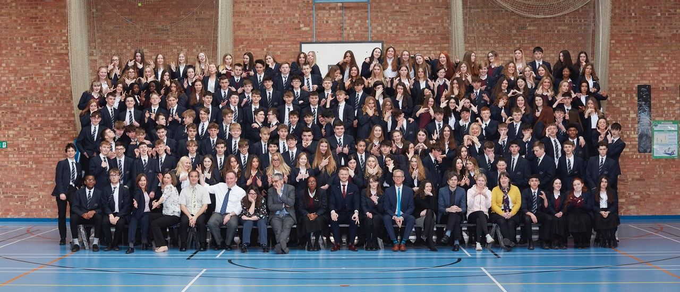

Finally, I just wanted to reassure you about a number of things. Primarily, you will be treated fairly with regard to your qualifications and the vast majority of young people across the country will be able to access their chosen post-16 pathway. I also want to remind you that you are still UCC students; this means that if you need to contact us about anything at all, then you can most certainly email the most relevant person and they will help you with what you need.
Thank you all for being such a fantastic year group; it was a pleasure working with you. Please stay safe and well.
Yours faithfully,
Mr B Solly.

