Year 11
Post-16 Event
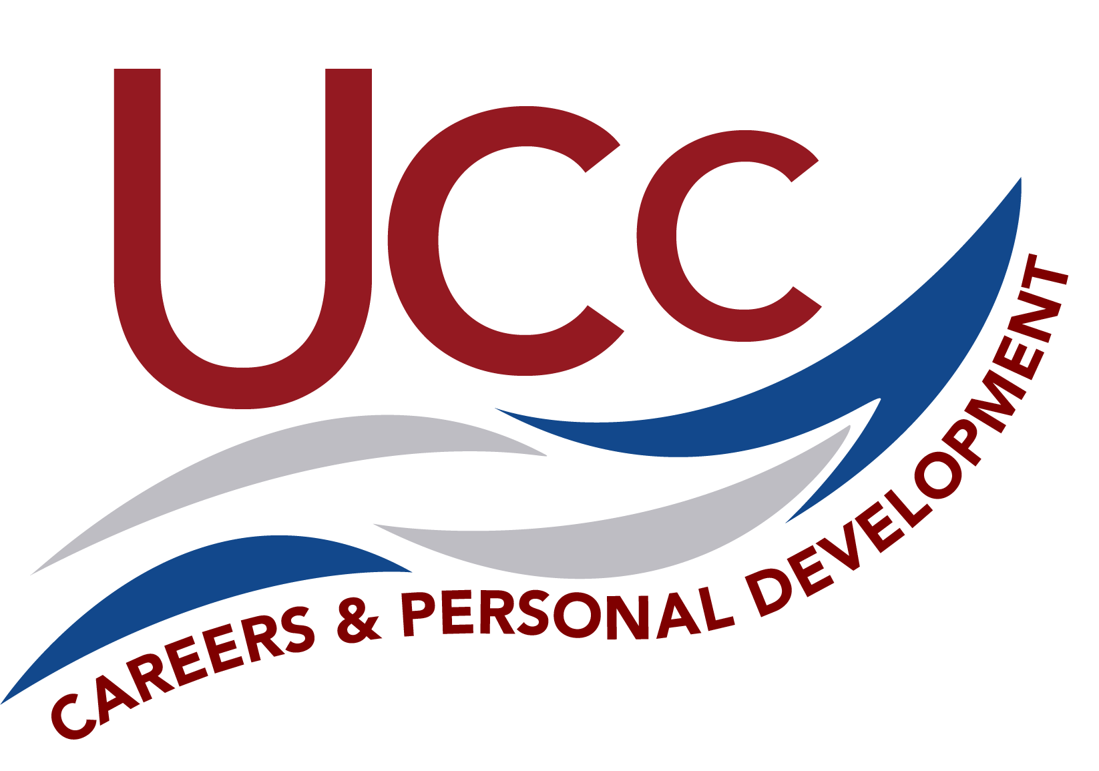Student and Parent Guidance

Objectives:
To provide students an opportunity to network with post-16 providers.
To provide students the opportunity to explore post-16 options to make informed choices.

Preamble:
Students are now moving towards a major career decision making stage of their academic journey and it is important that they are fully prepared to make proper informed decisions. There are several Post 16 options available to them, but every student must continue their educational journey in either education or training.

What suits one person may be completely different to what might suit another and there are many things to consider before they make those big decisions.

In Year 10, students received 5 x 30-minute sessions which focused on post-16 education, the application process and making informed choices. The most important message that was communicated was having a Plan A and a Plan B. Many students will already have an idea of the route they would like to take but they also need to consider a Plan B. What happens if Plan A doesn’t work out; they will need to consider alternative routes. For example, there is still a belief that A Levels are the best route into university. This isn’t necessarily the case. Our event provides students the opportunity to explore different routeways by networking with different providers, which could help them develop Plan A and Plan B.

Overview:
The event will be attended by many local post-16 providers who are wanting to discuss their offer and demonstrate what courses they have available. There will be representation from sixth forms, further education colleges, specialist colleges and employers.

The evening is an opportunity for students and parents to network and find out about post-16 options available in the local area and further afield.

The event starts at 5:30pm and ends at 7:30pm. Students and parents are invited to attend at any time. Our guests will be in the main drama studio and surrounding rooms and are looking forward to meeting as many students as possible and answer any questions they may have. The evening is very informal and a chance to network, therefore no need to make any appointments.

Post-16 – What it Means:

All students must either:
- stay in full-time education - for example at school, sixth form college, further education college or University Technical College (UTC)
- start an apprenticeship or traineeship
- spend 20 hours or more a week working or volunteering while also doing part-time education or training
Staying in Full Time Education:
Students could take a range of subjects that lead to qualifications that keep your options open, like A levels. Courses like T Levels or BTEC allow students to focus on a chosen career area like construction, healthcare science or digital careers. Some careers may ask for specific qualifications, so students should always do some research into where the course you are interested in might lead.
Combine Work and Study:
Students can gain practical skills, get work experience and a qualification that employers need through traineeships, supported internships, apprenticeships and school leaver schemes.

What is Available?
There are many options available to students post-16. The most common pathways are:

A Levels
T Levels
Vocational and Technical Qualifications
Applied Qualifications
Traineeships
Apprenticeships

A Levels:

Carry on studying subjects you took for GCSE to a higher level or pick new ones you may not have done before like economics, law or psychology. You could take 3 very different subjects you are interested in to keep your career options open or choose more closely related subjects if you need them for a specific career.

Duration: 2 years

Assessment: Mostly exams at the end of the course
Level of study: 3

Entry requirements: Typically, 5 GCSEs Grade 9-4 (usually including English and maths)

Leads to: University or college courses, higher and degree apprenticeships, work

Find out more: UCAS Information about A levels

T Levels
Designed in partnership with employers to give you the skills and knowledge to get on in the workplace. You'll combine classroom learning with real work placements. 1 T Level is the equivalent of 3 A levels.
Duration: 2 years
Assessment: Exams, projects, and practical assignments
Level of study: 3
Entry requirements: Course dependent
Work experience: At least 45 days on industry placement
Leads to: Work, higher and degree apprenticeships, college, and university courses
Find out more: Gov.uk information about T Levels

Apprenticeships:
Intermediate, advanced higher and degree apprenticeships combine practical on-the-job skills training with off-the-job learning. You'll get training that is relevant to your job and be paid a salary. Start at a level to suit you, with support if you have special needs or a disability.
Location: You’ll spend 80% of your time in the workplace and 20% off-the-job with some study in a college, training centre or Institute of Technology (IoT)
Duration: A minimum of 1 year
Entry requirements: Will be dependent on the industry, job role and apprenticeship level
Qualifications: apprenticeship certificate, diploma, degree and masters depending on level
Leads to: Work, next level of apprenticeship, further education, higher education
Find out more: Gov.uk information about Apprenticeships

Vocational and Technical Qualifications:
These courses teach you the practical skills and knowledge for a particular area of employment. They can prepare you for a broad employment sector, like engineering or travel and tourism, or for a specific job like a chef or a hairdresser. Qualifications which teach you how to do tasks specifically related to the industry and role you want to be involved in.
Duration: 1 or more years
Assessment: Can include coursework, skills tests and exams
Level of study: 1+
Entry requirements: Course dependent
Work experience: You'll learn in real situations in college, for example in a college restaurant or a salon that is open to the public. You may also have the chance to go out on a work placement with an employer.
Leads to: Apprenticeship, work, college or university

Top Tips:
Here are tips to help you get the most from your evening:
KNOW:
- Know what interests you. When you are looking at the next steps it is important to know which subjects you enjoy and which ones you are good at.
- Know your own skills. It is always important to know what skills you are good at as they might be that some courses suit your skill set better. Have a go at describing yourself in 5 words so you identify your strengths.
- Know about assessment. Think about how you like to be assessed as courses have different assessment methods. For example, some will make you sit an exam at the end, and some will do it through continuous coursework.
- Know your grades. Have an idea of what sort of grades you are likely to get in each subject. You will have an idea from past reports. If you are not sure, try asking your teacher before you attend.
- Know your limits. Come prepared with some thoughts about where you would like to study. You might need to consider travel arrangements etc.
FIND:
- Find out about entry requirements from the providers you visit.
- Find out about travel arrangements such as do they provide transport and how much.
- Find out about their expectations for things such as uniform, equipment, attendance.
- Find out about the opportunities they offer beyond the classroom.
- Find out about how they can support you gaining post-18 places.
- Find out about their application process, such as deadlines and how to apply.
REFLECT:
- How’s your behaviour and attitude at school? Some providers may ask you.
- Do you have a personal profile? Some providers like students to be involved in other opportunities beyond the classroom.
- Do you want a school or college environment. Some providers have strict policies on uniform etc.
- Why them? Some providers might ask why you are thinking of applying for them and are you are applying because it is the right place for you.
- Do you have a plan? It is important to know if your post-16 decision is part of a bigger career plan.

Who will you meet:

Below is a list of all our confirmed attendees and links to their websites. This is the best way to find out about entry requirements, courses, open evenings and any upcoming events:
Richard Gray | Armed Forces Careers Office - Royal Navy | Website Link
Andrew Hallas | Corby Technical School | Website Link
Oliver Teasel | Harington School | Website Link
Natasha Roberts | MV16 | Website Link
Laura Thorpe | Moulton College | Website Link
Haydn Cahill | National Horse Racing College | Website Link
Rosie Maclennan | New College Stamford and Peterborough Regional College | Website Link Stamford College  Website Link PRC
Anna Steigar | Oakham School | Website Link
Andy Murphy | Stamford School | Website Link
Trudie Tebbutt | Tresham College of Further Education/Bedford College Group | Website Link Tresham  Website Link BCG
Charlie Bostock | Uppingham School | Website Link
Dee Kavia | Wyggeston and QE | Website Link
Lucy Willis | King’s School Peterborough | Website Link

Although these are the confirmed attendee’s, we do expect there to be representatives from other providers.

Further Information:
Here are some useful links that could help you with your planning:
UCC Careers and Personal Development: Our website contains useful information for students and parents Use this link to access the information.
National Careers Service: The NCS have put together a guide, which is available from GOV.uk. Use this link to access the information.
UCAS: UCAS have developed an information page about post-16 and options available after GCSE exams. Use this link to access the information.
Career Pilot: Career Pilot have a parent zone which explores post-16 education. Use this link to access the information.

