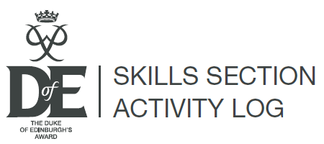
NAME:

LEVEL (Bronze, Silver or Gold:

TIMESCALE: (No. of months for this section)

Notes:
- If extra space is needed, use an additional log.
- This Activity Log is only a personal record of the time you spend on your activities for each section.
- Remember to add this information, along with scans, photographs etc. (as high resolution jpegs) as evidence into eDofE to ensure that your Achievement Pack will be a real reflection of your DofE activities.
- Download extra copies of this Activity Log, plus logs for the other sections, from www.eDofE.org or www.DofE.org/go/downloads
- For Expedition/Residential records, please refer to the Keeping Track booklet.
- You can ask your Assessor, Leader, instructor, trainer, coach, mentor etc. to initial each entry.
Date | What you did | Hours | Initials

Date | What you did | Hours | Initials

